HW4-DOAN MANH HUNG

P

L

b

h

Cross section

b=20mm,

h=50mm, 100mm, 200mm.

Number of elements: 20

1. Calculate the displacement by using:

* Euler-Bernoulli theory.
* Timoshenko theory.

1. For h=10mm, 1mm, 0.1mm. What’s happen when using Timoshenko?

For Euler-Bernoulli theory:

$$Ke=\frac{EI}{{Le}^{3}}\left[\begin{matrix}\begin{matrix}12 & 6Le \\ 6Le & 4{Le}^{2}\end{matrix} & \begin{matrix}-12 & 6Le \\ -6Le & 2{Le}^{2}\end{matrix} \\ \begin{matrix}-12 & -6Le \\ 6Le & 2{Le}^{2}\end{matrix} & \begin{matrix}12 & -6Le \\ -6Le & 4{Le}^{2}\end{matrix}\end{matrix}\right]$$

For Timoshenko theory:

$$Ke=GA\left[\begin{matrix}\begin{matrix}\frac{1}{Le} & \frac{1}{2} \\ \frac{1}{2} & \frac{Le}{3}+\frac{EI}{GALe}\end{matrix} & \begin{matrix}\frac{-1}{Le} & \frac{1}{2} \\ \frac{-1}{2} & \frac{Le}{6}+\frac{EI}{GALe}\end{matrix} \\ \begin{matrix}\frac{-1}{Le} & \frac{-1}{2} \\ \frac{1}{2} & \frac{Le}{6}+\frac{EI}{GALe}\end{matrix} & \begin{matrix}\frac{1}{Le} & \frac{-1}{2} \\ \frac{-1}{2} & \frac{Le}{3}+\frac{EI}{GALe}\end{matrix}\end{matrix}\right]$$

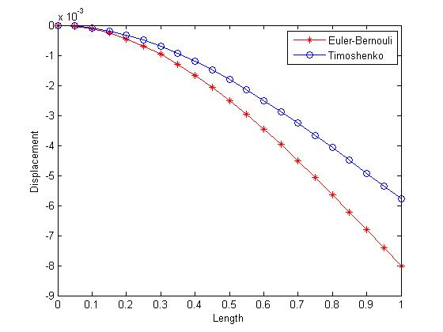h=50mm

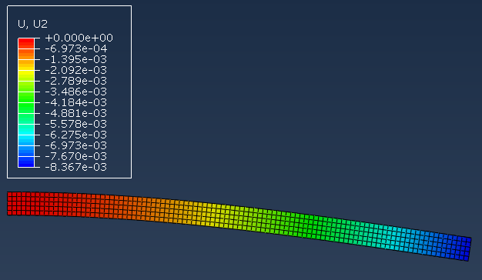

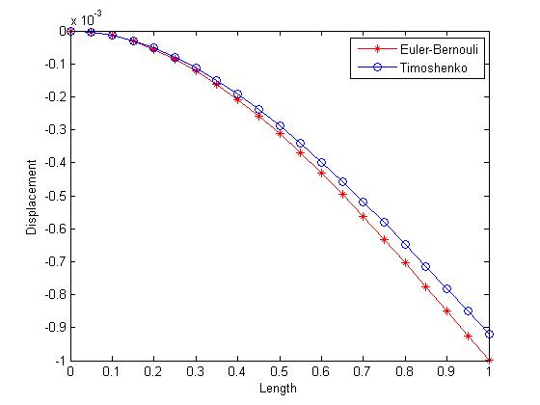h=100mm

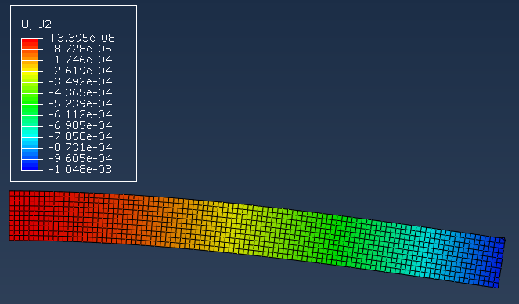

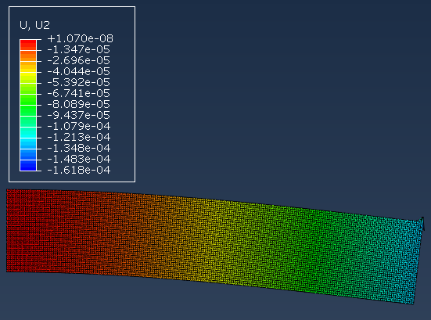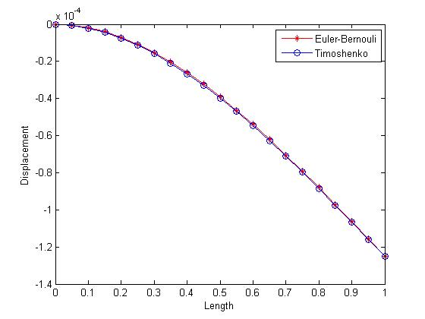h=200mm

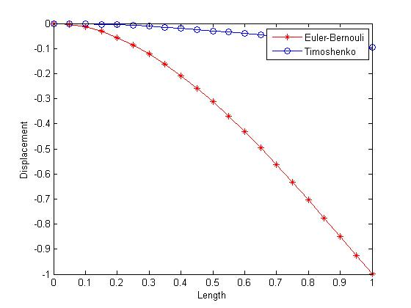h=10mm

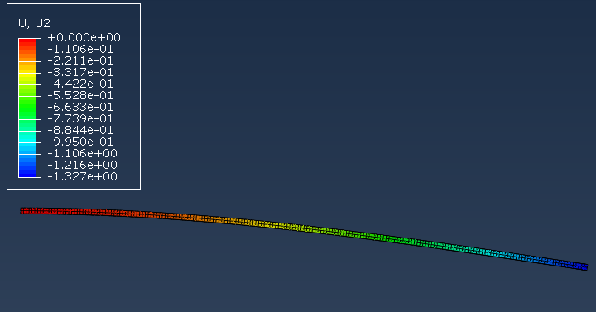

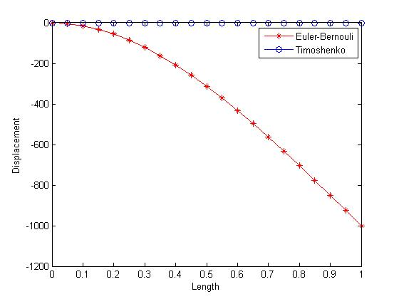h=1mm

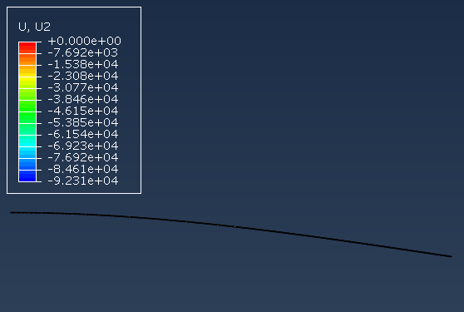

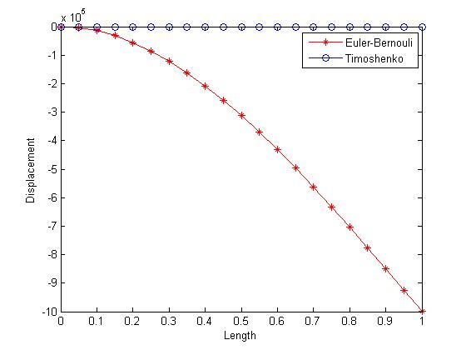h=0.1mm